**CARAVAN EVENTS COMPANY PROFILE**

**ABOUT US**

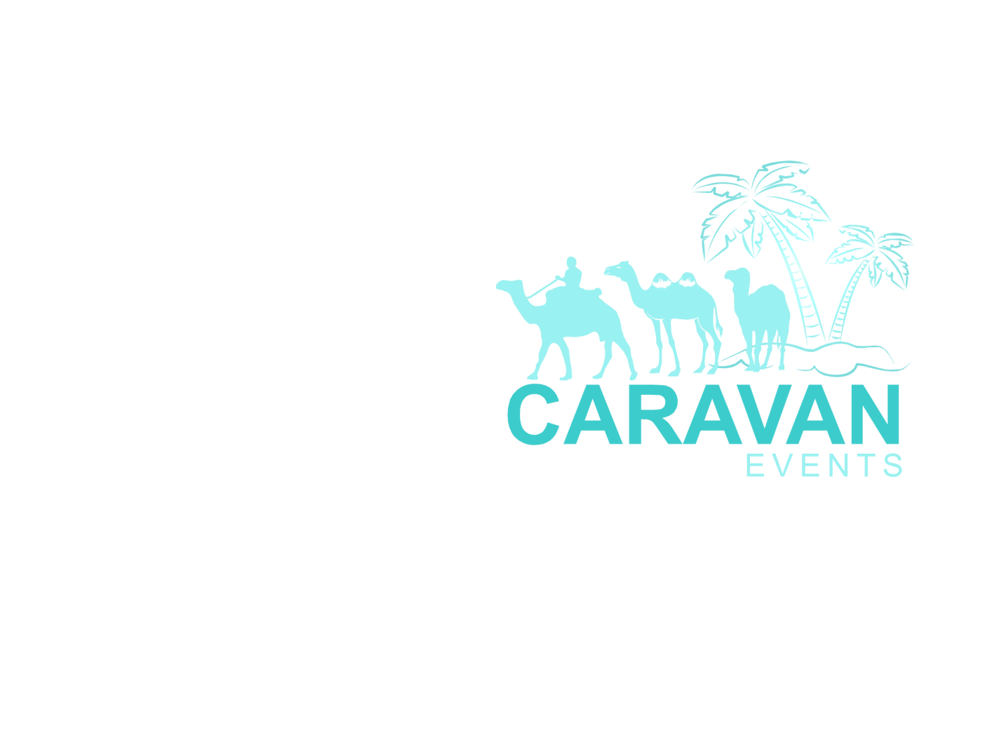Caravan Events is a full service, social and corporate event planning Company with a focus on wedding and event coordination and planning, Emcee services, Dj Services, theatre productions, Poetry and music band, PA and sounds services based in Nairobi, Kenya. Our innovative approach to planning exquisite and memorable events, unmatched creativity and extraordinary attention to detail, combined with our professionalism and excellent service delivery, makes Caravan one of the premier event companies and your one stop for all your Event and entertainment needs. We take out the headache out of trying to choose the best professionals, décor, coordinating the event and entertainment – we know every detail matters. Quality and personalized service is our specialty. We provide a dedicated, professional meeting to each of our clients with their selection of one of our packages. We ensure to deliver on all facets of each event, ensuring seamless execution and excellent customer service to develop an event that our client and their guests will forever remember. Our mission and values outline who we are, what we seek to achieve and how we want to achieve them.

**WHAT WE DO**

Creating extraordinary events is our specialty, innovative designs, entertainment and customized themed décor. Caravan Events delivers resonance that will blow your mind away while saving our clients valuable time and money. We offer the below services:

1. **Corporate Events**

Caravan’s event planning and onsite management service offering ensures that every facet of your event or program is professionally coordinated, allowing your clients to enjoy the experience and realize maximum productivity. Whether you need assistance with the planning and management of a company awards, banquet, staff party, a cocktail event, or a charity fund raiser; Caravan Events has the right personnel, coordination package, and approach to satisfy even the most discriminating palette.

1. **Weddings**

Caravan’s wedding service delivers an intimate relationship with each client and caters to their personal taste, preferences, and overall event desires. We are committed to making this process stress-free. Caravan team delivers unparalleled service, expertise, and quality. We will create a one-of-a kind, extraordinary and exquisite event just for you.

We not only collaborate with the finest vendors and veteran industry professionals; we stay current by consulting with the new, chic, and fresh-faced innovators in the art of luxury and creativity. The end result is a customizable coordination package that is best suited for the bride and groom. The client thinks it we make it a reality. Once a package selection is made, Caravan will manage the event from inception to completion, so the happy couple can enjoy this blissful time in their life.

1. **Custom Events**

We as the Caravan team realize that a custom event can range in size, scope, budget and complexity. Whether it's an intimate dinner party for ten in a private home, a graduation party to celebrate the hard work or an outrageous fortieth birthday celebration or just an awesome themed birthday party for the 2 year old. Caravan does it all! Our goal is to create an event that best fits your unique style and needs, while not only meeting but exceeding your expectations. We ensure that we deliver an extraordinary and seamless event that you and your guests will remember for a life time.

1. **Poetry and Music**

The Caravan Band has a poet and band that specializes in writing and performing customized poetry for an array of events including weddings, corporate events and special occasions.

The poems are customized to tell the story of the couple for weddings with band playing an array of selected music by the couple.

All bookings include;

1. **Consultation and interview:** every detail in a story is always important and the poet seeks to capture that moment in a creative poetic way making you relive the moment once again. The poet will use the information and begin writing an intimate experience through personalized stories. A rough draft of the poem will be sent to you for review before the event.
2. **Live performance:** on the day of the event the poet will perform while the band plays and sings complimenting music gently in the background. The customized poem describes your relationship as well as the specific activity in the event at the same time.
3. **Recordings:** the band and the music producer work side by side to come up with music designed to fit the mood, ambience and ‘flow’ of the poem. This makes the event more unique and distinct. Up to 2 rough drafts of the poem and music will be sent to you for review before the event.
4. **Keepsake items:** the keepsake audio/video CD and cards are meant to help you remember your special day as often as you desire. When you pull out your video you can as well watch the poetry and relive the moments once again. The custom poem is written in a standard card stock paper in standard artwork, custom art comes at a fee. The audio CD includes a studio recording of the poem and music.
5. **Emcee**

Caravan has a variety of hilarious emcees who will keep you and your guests entertained.

1. **Sound and lighting**

A good lighting changes everything in an event. It brings the event to life. At Caravan we provide state of the art lighting services for your events. We are bent to provide quality light and sound systems to your event. Our sound system comes with homeboyz trained Djs and a back-up generator.

1. **Bridal gowns and dresses**

Caravan Event has a team of seamstresses who are talented and creative in bringing to life the gown, bridesmaid dresses of any design that you have in mind. With a range of designs Caravan bridal team provides custom alterations to gowns and other dresses. The team can truly offer a bride her dream gown. She goes over the sketches with the client and delivers.

**MISSION**

* To provide our clients with the most amazing entertainment services. Caravan promises to make any event the memorable event ever.
* To be a passionate, trusted, and dedicated team of event professionals committed to providing extraordinarily flawless events that supply our clients with seamless management, timeless style, unforgettable experiences, and the highest quality.
* To anticipate our clients' needs and deliver exceptional service and products.
* To meet our clients' event objectives while exceeding their expectations.
* To provide a great place to work, where our staff is inspired to work to their full potential, and encouraged to find balance in life between their commitments to family, community, and continued education.
* To remain a premier special event and entertainment company while maintaining our mission and values.

**VALUES**

* **Integrity:** We provide a fair price for the services that we offer with complete transparency. Our clients will always know how their event resources are allocated.
* **Passion:** We don't believe in the status quo, our goal is to not meet expectations but to exceed them.
* **Accountability:** The Caravan team is personally invested in your event and as your trusted partner we deliver…guaranteed!
* **Creativity:** Caravan has an energetic and innovative team who will deliver to the satisfaction of our clients.
* **Quality:** We have working relationships with vendors who share our mission and values in all price points.
* **Professionalism:** Our clients are our top priority and we treat them with the utmost respect and courtesy at all times.

**BUSINESS GOALS AND OBJECTIVES**

We strive to plan and implement the perfect event experience that clearly communicates our clients’ vision and exceed their goals.



**OUR PREVIOUS EVENTS**

**DECOR**

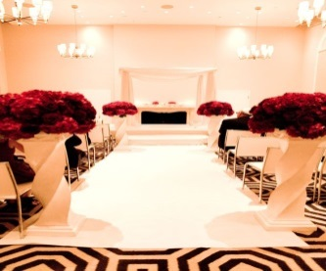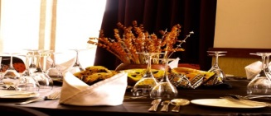

**SWAHILI THEMED WEDDING AT BOMA INN**

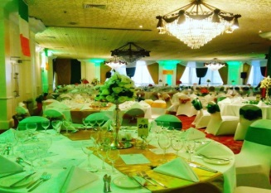

**HILTON HOTEL IRISH HOLIDAY-CORPORATE EVENT**

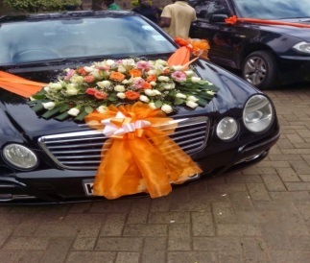

**ORANGE THEMED WEDDING AT PRIDE INN**

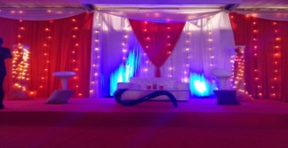

**SWAHILI THEMED WEDDING AT PRIDE INN**

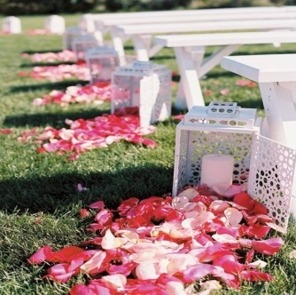

**GARDEN WEDDING AT OLOLUA KAREN**

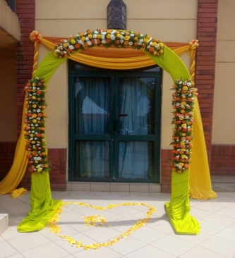

**WEDDING AT BOMA INN**

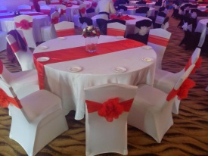

**HENKEL KENYA LTD END YEAR PARTY AT RUARAKA**

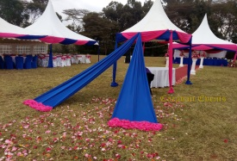

**GARDEN WEDDING AT SOS GROUNDS BURU BURU**

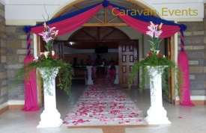

**WEDDING AT ACK BURUBURU**

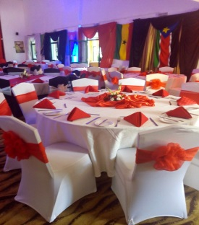

**BEMLAM INVESTMENTS STAFF PARTY**

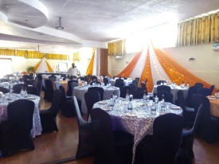

**SAGOO AUTOMOBILE STAFF DINNER**

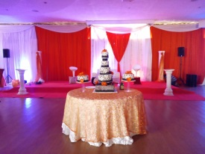

**WEDDING RECEPTION AT WATERBUCK HOTEL**

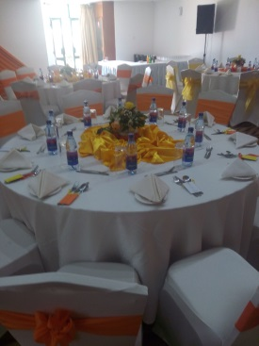

**ILANI ENTERPRISES AGM**

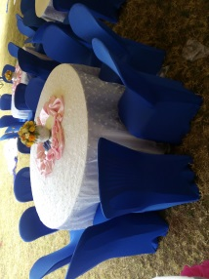

**BARCLAYS MAKE A DAY DIFFERENCE DAY**

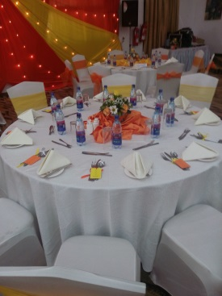

**SAGOO RADIATORS ANNIVERSARY PARTY**

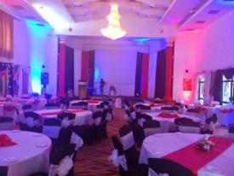

**ASIAN THEMED PARTY AT PANARI HOTEL**

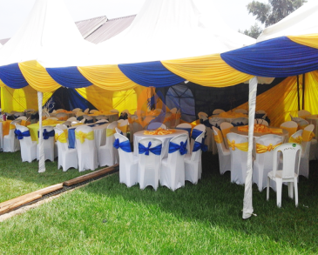

**AGRO-CHEMICALS STAFF PARTY**

**BAND PERFORMANCES**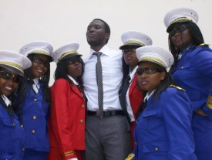

**CARAVAN BAND AT KENYA PORTS AUTHORITY AGM**

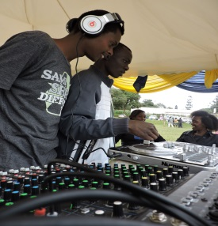

**DJ KONECT AT AGRO-CHEMICALS AGM**

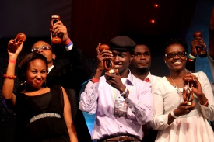

**CARAVAN BAND AT NAIROBI CAMPUS AWARDS-WINNERS MOST PROMISING BAND 2016**

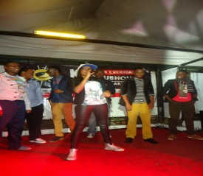**CARAVAN BAND AT MOMBASA CEMENT STAFF PARTY**



**CARAVAN BAND’S LEAD VOCALIST AT TUSKER PROJECT FAME**

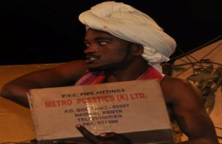

**CARAVAN’S EMCEE EDWARD AT KALUWORKS AGM**

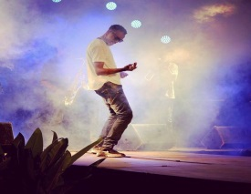

**CARAVAN BAND’S MALE VOCALIST MUOK JR. AT PARAGASHA**

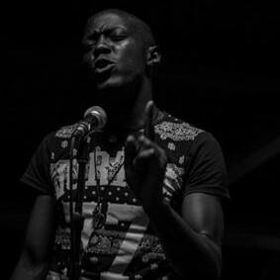

**CARAVAN BAND’S LEAD POET-MIMA-AT RED CROSS DINNER AT RED COURT NAIROBI**



**CARAVAN BAND’S LEAD VOCALIST AT H-YOUNG E.A COMPANY-SAFARI PARK HOTEL**



**CARAVAN BAND AT KALASHA AWARDS WINNERS BEST STAGE SCRIPT**

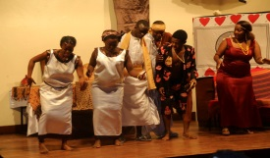**CARAVAN THEATRE CUSTOMIZED PERFORMANCE AT KENYA NATIONAL THEATRE**

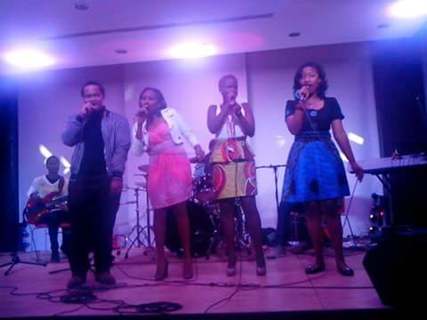

**CARAVAN BAND AT SAUTI ACADEMY GRADUATION**



**CARAVAN BAND AT KICC MINISTRY OF FOREIGN AFFAIRS CONFERENCE**

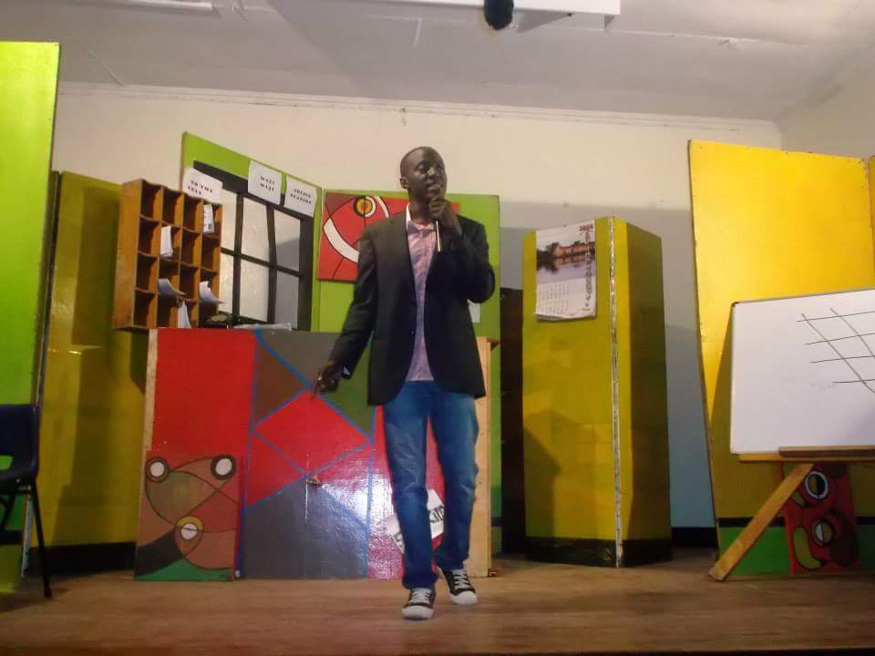**CARAVAN BAND’S LEAD POET EMCEEING AT BRITISH HIGH COMMISSION FLIP ART FAIR**



**CARAVAN BAND’S LEAD POET PERFORMING AT NDIMI ZETU AT BOMB BLAST MEMORIAL PARK**

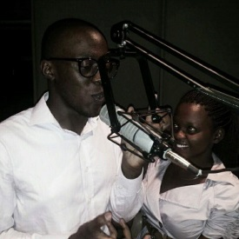

**CARAVAN BAND RECORDING SESSION**

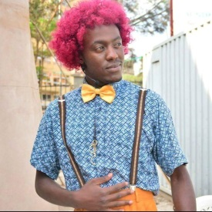

**CARAVAN BAND HILARIOUS EMCEE AT CARNIVORE**

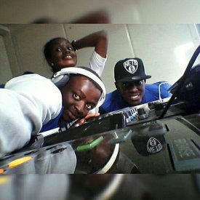

**CARAVAN TOP DJS, DJ WIGGO,DJ DRUFF N DJ LE QUARK AT FLOODLIGHTS RUGBY IMPALA GROUNDS**

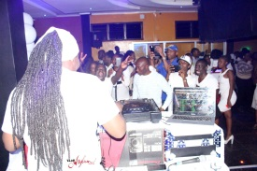

**CARAVAN DJS AT CLUB ASYLUM WHITE PARTY**

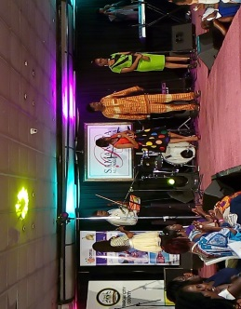

**CARAVAN BAND AT SAMANTHA BRIDAL FAIR**

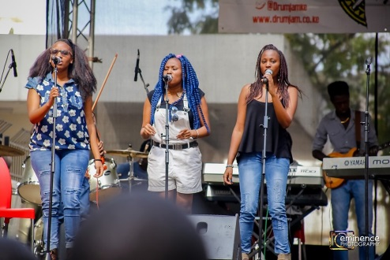

**CARAVAN BAND PERFORMING AT DRUM JAM AT ALLIANCE FRANCAISE**

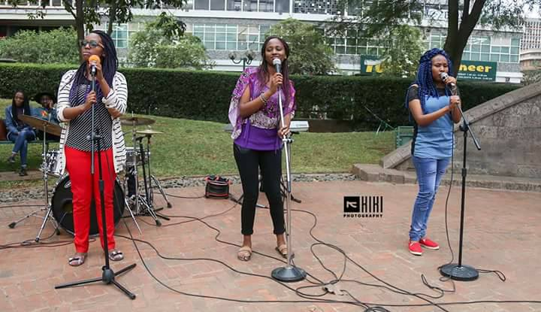

**CARAVAN BAND PERFORMING AT NDIMI ZETU AT THE MEMORIAL PARK**

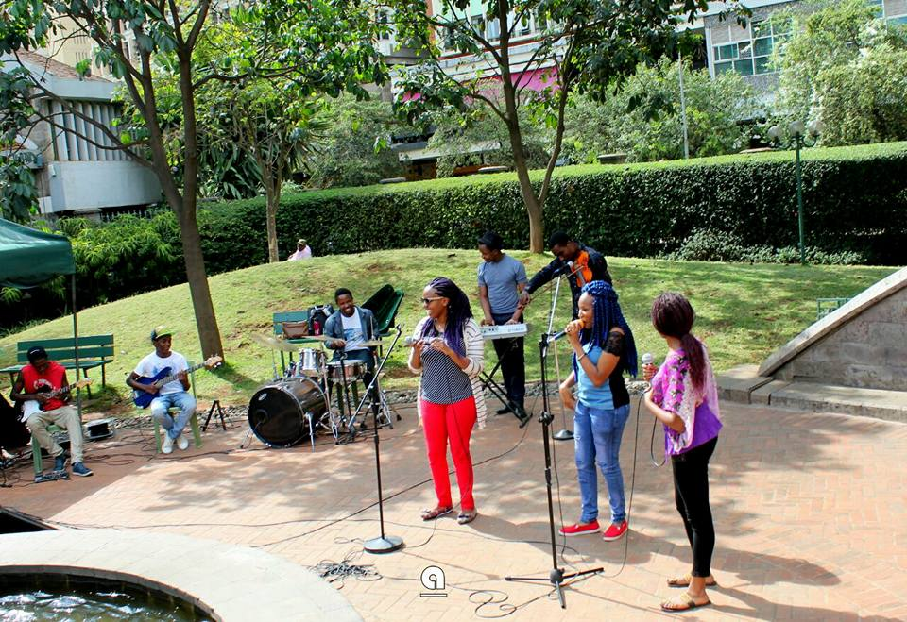

**CARAVAN BAND AT NDIMI ZETU AT THE MEMORIAL PARK**